The National University of Lesotho
Department of Mathematics and Computer Science
Faculty of Science and technology

CS4433: Software Engineering
Task: Phase 2 Requirements engineering
‘Mafusi Motsoari
202322797

1.Stakeholder Analysis
Stakeholders | Interests
Principal | Wants a simple system and ensures students only see marks after HoD approved them.
Lecturer | Wants to create assignments, set deadlines, mark submissions, give feedback and grant extensions.
Head of Department | Wants late work to lose 10% of the available marks per day for up to three days, after which it receives zero. Needs to review all departmental marks before release.
Students | Wants to submit, resubmit assignments, receive written feedback and view released marks.
IT Officer | Wants the system to work offline because of the internet is unreliable, protect passwords and respond quickly while supporting 800 students.
System Administrator | Wants to manage user accounts, departments, courses, lecture assignments and student enrolments.

2. stakeholder conflicts and their resolution
Conflict | Resolution
The lecture wants students to receive their marks as soon as the work has been marked, but the principal requires the HoD to check the marks first. | Lecture can mark submissions and provide feedback, but marks remain hidden until the HoD approves and releases them.
The HoD want late submissions to lose 10% of the available mark per day, while students do not want late submissions to be rejected. | Accept late submissions for up to three days, deduct 10% of the available mark per day, and award zero after three days.
Students want to correct mistakes and resubmit work, but assignment have deadlines. | Allow students to correct mistake mistakes and resubmit their work before the deadline.
Lectures want to provide extensions to students with valid reasons, but assignments deadlines must still be enforce. | Allow lectures to provide individual extensions to students and record the revised deadlines.

3. Software Requirements Specification (SRS)
3.1 functional Requirements
MoSCoW:
- Must
- Should
- Could
- Won’t
ID | Functional Requirements | Priority | verification
FR-01 | The system shall allow registered users to log in using a username and password. | Must | Test login using valid and invalid usernames and passwords.
FR-02 | The system shall have a role based access control for students, lectures, HoDs and administrators. | Must | Test access permissions for all four user roles.
FR-03 | The administrator shall be able to create, update and deactivate user accounts. | Must | Create, update and deactivate user accounts, then verify that each operation works correctly.
FR-04 | The admin shall manage departments, courses, lecture assignments and student enrolments. | Must | Test each management operation and verify that the changes are saved correctly.
FR-05 | Lectures shall be able to create assignments with deadlines and maximum marks. | Must | Create assignments using valid and invalid deadlines and maximum marks and verify that invalid data is rejected.
Fr-06 | Lectures shall be able to grant individual students deadline extensions. | Must | Grant an extension to a student and verify that the revised deadline is saved and applied correctly.
FR-07 | The system shall identify late submissions and apply the late late-penalty rules. | Must | Test submissions made on time and 1,2,3 and more than 3 days late and verify the correct penalty for each case.
FR-08 | Lecture shall be able to mark submissions and provide written feedback. | Must | Enter marks and feedback, save them and verify that the correct information is stored and retrieved.
FR-09 | HoDs shall review and moderate marks for courses in their departments. | Must | Log in as the HoD and verify that they can review and moderate marks within their department but cannot access courses outside their department.
FR-10 | The system shall prevent the students from viewing marks before the HoD approval and release. | Must | Log in as a student and attempt to view unreleased marks. Verify that the marks are not displayed.
FR-11 | HoDs shall release approved marks to the relevant students. | Must | Release approved marks and verify that the correct students can view their own released marks.
FR-12 | The system shall record every mark change, including the user, time, previous mark, new mark and reason. | Must | Change a mark and verify that the audit log records all five required details correctly.
FR-13 | The system shall retain course, submission, mark and feedback records after the program closes. | Must | Save the records, close and reopen the application, and verify that all records remain available and unchanged.

3.2 Non-Functional requirements
ID | Functional Requirements | Priority | verification
NFR-01 | The system should complete a login operation within 2 seconds when 800 student accounts are stored. | Must | Measure login response time with 800 student accounts stored.
NFR-02 | The system shall operate without an internet connection on the school's computer or local network. | Must | Disconnect the internet and test the system's core functions.
NFR-03 | The system shall store passwords using salted hashes rather than plain-text passwords. | Must | Inspect the stored password data to verify that passwords are not stored in plain text.
NFR-04 | Lectures and HoDs should be able to create assignments or mark submissions in fewer than 5 steps. | Should | Ask users with basic computer skills to complete these tasks and count the steps.
NFR-05 | The business logic shall achieve at least achieve at least 70% automated unit test line coverage. | Should | Generate a test coverage report and verify that coverage is at least 70%.
NFr-06 | The system shall save changes to the database so that the remain available when the system is reopened. | Must | Save data, close the system and reopen it to check that the data remains available.

4. use case
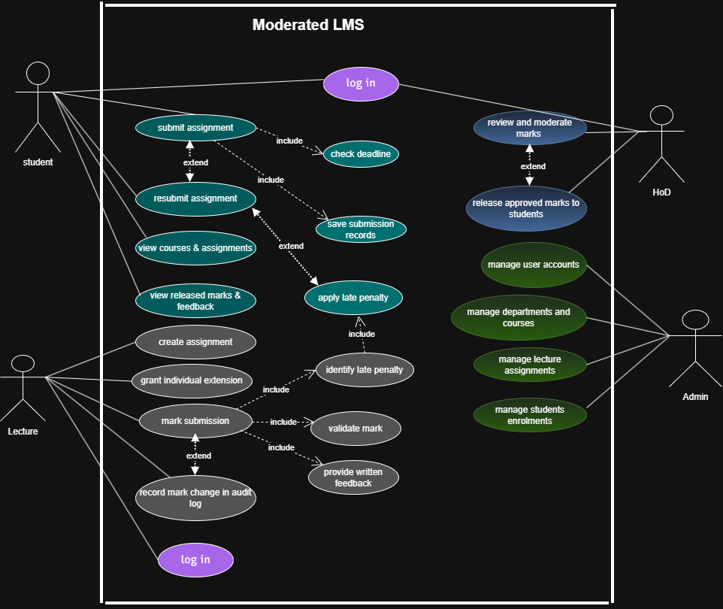
Business rule
- BR-01: users must log in before accessing protected system functions.
- BR-02: each user may perform only the actions allowed by their assigned role.
- BR-03: students may view marks only after the HoD has released them.
- BR-04: late work loses 10% of the available mark for each day late, for up to three days.
- BR-05: work submitted more than three days after the applicable deadline receives zero.
- BR-06: students may resubmit work before the applicable deadline.
- BR-07: lecturers may grant individual extensions, and the revised deadline must be recorded.
- BR-08: every mark change must record the person responsible, the time, the old mark, the new mark and the reason.
- BR-09: The HoD must review and moderate departmental marks before releasing them.
5. Use Case Specifications
5.1 Use Case1: Submit Assignment
Primary actor: Student
Goal: submit assignment work and, where permitted, replace an earlier submission for a course in which the student is enrolled.
Preconditions:
- The student is logged in.
- The student is enrolled in the relevant course.
- The assignment exists and is available to the student for submission.
Trigger: the student selects an assignment and chooses to submit work
Main Success Flow:
- The student logs in to the system.
- The system displays the student's enrolled courses.
- The student selects a course.
- The system displays the assignments for that course.
- The student selects an assignment.
- The system displays the assignment details, including the deadline and maximum mark.
- The student selects the submission option and provides the assignment work.
- The system checks the applicable deadline.
- The system saves the submission and records its submission time.
- The system sets the submission status to submitted.
- The system confirms that the submission has been saved.

Alternative flows:
- A1: Resubmission: If a previous submission exists and the applicable deadline has not passed, the student submits a replacement. The system records the new submission.
- A2: Late submission: If the submission is late but within the permitted three-day period, the system accepts it and applies the relevant penalty.
- A3: Extension: If the student has an authorised extension, the system checks the revised deadline.
Exception flows:
- E1: If the student is not enrolled in the course, the system rejects the attempt.
- E2: If the submission cannot be saved, the system displays an error and does not report a successful submission.
- E3: If the submission is beyond the permitted late period, the system records the outcome according to the approved late-work rule and awards zero.
Postconditions:
- A valid submission is stored with its student, assignment and submission time.
- Its status is set to submitted or late
- The submission is available to the lecturer for marking.
Business Rules:
- BR-01: The student must be logged in.
- BR-02: The student must be enrolled in the course.
- BR-04: Late work receives the specified penalty.
- BR-05: Work more than three days late receives zero.
- BR-06: Resubmission is allowed before the applicable deadline.
- BR-07: An approved individual extension changes the applicable deadline.
5.2 Use Case 2: Mark Submission
Primary actor: Lecture
Goal: to assess a student’s submission and record a mark and written feedback.
Preconditions:
- The lecture is logged in and assigned to the relevant course.
- The submission exists and the lecture has access to it.
- The submission has been saved.
Trigger: the lecture selects a submission for marking.
Main Success Flow:
- The lecturer logs in to the system.
- The system verifies the lecturer's role and permissions.
- The lecturer selects an assigned course.
- The system displays the assignments and their submissions.
- The lecturer selects a submission.
- The system displays the submission and relevant assignment details.
- The lecturer assesses the work.
- The lecturer enters the mark.
- The lecturer enters written feedback.
- The system checks that the mark is valid and does not exceed the maximum available mark.
- The system applies the specified late penalty where applicable.
- The system saves the mark and written feedback.
- The system updates the submission status to marked.
- If an existing mark has been changed, the system records the required audit details.
- The system confirms that the mark and feedback have been saved.
Alternative Flows:
- A1: The lecturer changes an existing mark; the system records the old mark, new mark, user, time and reason.
- A2: The system identifies a late submission, applies the appropriate penalty and saves the adjusted mark and feedback.

Exception flows:
- E1: A mark below zero or above the maximum is rejected.
- E2: The lecturer omits the required mark or written feedback; the system requests the missing information.
- E3: A database error occurs while saving; the system informs the lecturer that the changes could not be saved and does not confirm success.
Postconditions:
- The mark and feedback are stored.
- All successful mark changes have audit records.
- The result remains hidden from students until it is approved and released.
Business Rules:
- BR-01: users must log in before accessing protected system functions.
- BR-02: each user may perform only the actions allowed by their assigned role.
- BR-04: late work loses 10% of the available mark for each day late, for up to three days.
- BR-05: work submitted more than three days after the applicable deadline receives zero.
- BR-07: lecturers may grant individual extensions, and the revised deadline must be recorded.
- BR-08: every mark change must record the person responsible, the time, the old mark, the new mark and the reason.

5.3 Use Case 3: Release and Review Marks
Primary actors: HoD and students
Goal: make approved marks and feedback available to the correct students.
Preconditions:
- The HoD is authenticated and authorized for the department. The marks have been reviewed and approved.
- The marks have been reviewed and approved.
Trigger: The HoD opens the departmental marks awaiting release.

Main Success Flow:
- The HoD logs in to the system.
- The HoD opens the departmental marks awaiting release.
- The system displays the results requiring release.
- The HoD reviews the results.
- The HoD selects the approved results for release.
- The system records the release status and time.
- The student logs in and opens the relevant course.
- The system displays the student's released mark and feedback.
Alternative Flows:
- A1: The HoD identifies an issue and withholds the affected result until it is corrected.
- A2: A student has no released result; the system displays an appropriate status instead of an unreleased mark.
Exception Flows:
- E1: A lecturer or student attempts to release marks; the system denies the operation.
- E2: A student attempts to access another student's results; the system denies access.
- E3: A database error prevents release; the system reports that the release has not been confirmed.
Business Rules:
- BR-01: users must log in before accessing protected system functions.
- BR-02: each user may perform only the actions allowed by their assigned role.
- BR-03: students may view marks only after the HoD has released them.
BR-08: every mark change must record the person responsible, the time, the old mark, the new mark and the reason.
- BR-09: The HoD must review and moderate departmental marks before releasing them.

